**Day 1**

1. **Moving Zeros To The End**

Level: 5

Link: <https://www.codewars.com/kata/52597aa56021e91c93000cb0/solutions/javascript?filter=me&sort=best_practice&invalids=false>

Code:

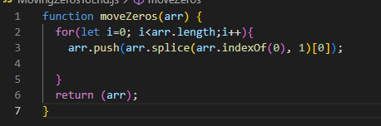

1. **Find Nearest square number**

Level: 5

Link:

<https://www.codewars.com/kata/5a805d8cafa10f8b930005ba/solutions/javascript?filter=me&sort=best_practice&invalids=false>

Code:

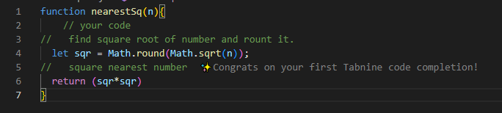

1. **Multiples of 3 or 5**

Level: 4

Link:

<https://www.codewars.com/kata/514b92a657cdc65150000006/solutions/javascript?filter=me&sort=best_practice&invalids=false>

Code:

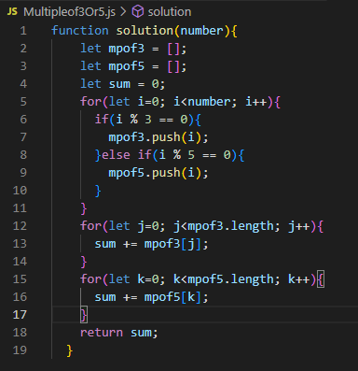

1. **Rot13**

Level: 5

Link: <https://www.codewars.com/kata/530e15517bc88ac656000716/solutions/javascript?filter=me&sort=best_practice&invalids=false>

Code:

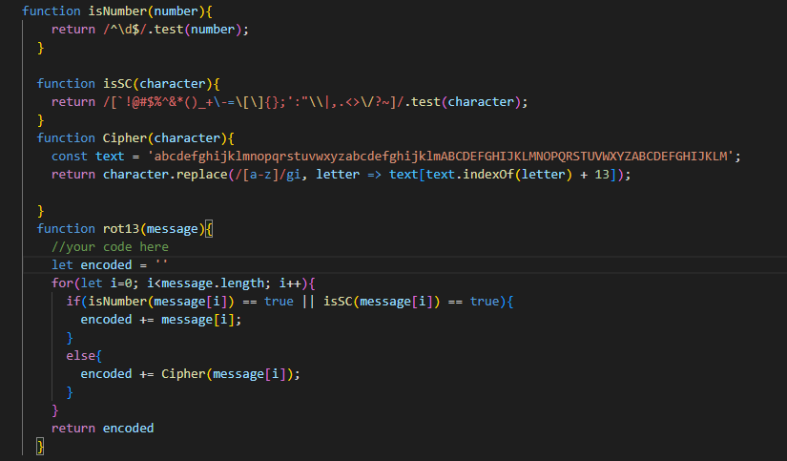

1. **Sum Strings as Numbers**

Level: 6

Link: <https://www.codewars.com/kata/5324945e2ece5e1f32000370/solutions/javascript?filter=me&sort=best_practice&invalids=false>

Code:

